WEB CONTENT

OUR TEAM

Professor Jeremiah Chakaya(CEO/Technical Director)

Professor Jeremiah Chakaya is a founding member of the Respiratory Society of Kenya (ReSoK) and serves as a member in the executive committee of the Pan African Thoracic Society. In April 2020 he took up a position as Professor for Global Respiratory Health at the Liverpool School of Tropical Medicine. He continues to serve as a technical expert for the Kenyan National TB Programme. At the international level, Prof. Chakaya has held several positions including, Vice Chair of the Stop TB Partnership Coordinating Board, Chair of the Strategic and Technical Advisory Group for TB (STAG-TB ) of the World Health Organization (WHO), Chair of the Global Fund’s Technical Review Panel (TRP) and President of the International Union Against Tuberculosis and Lung Disease ( the Union). He has an honorary teaching position at the school of medicine, Kenyatta University, Nairobi, Kenya.

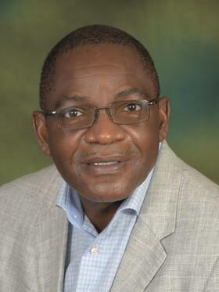

Mr Chrispine Okoth(Finance & Admin Manager)
Chrispine Okoth has been the Finance & Administration Manager at the Respiratory Society of Kenya (ReSoK) since 2009, bringing over ten years of financial management experience in the service and manufacturing sectors. His experience includes financial planning, directing, project management and execution, budgetary control, and grants management. In addition to his financial management duties, Chrispine is responsible for administrative tasks, including human resources management.

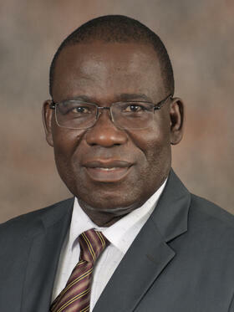

Dr Jacqueline Wanjiku Kagima (Director Training & Research)

As the Director of Training & Research at ReSoK, Kenya, Dr. Jacqueline Wanjiku Kagima aims to support the planning process for research uptake, including the development of tools for monitoring and evaluating research uptake activities. She ensures that research findings are translated into national and international policy and practice. Additionally, she oversees training programs to enhance the skills and knowledge of stakeholders. She believes that teamwork, collaboration, and partnerships are key to achieving these goals

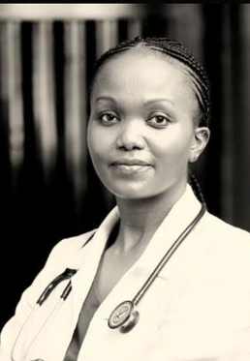

Ms Rhoda Pola(Research Coordinator - Light Consortium)

Rhoda, a research coordinator and field epidemiologist with the LIGHT Consortium since January 2024, is based in ReSoK, Kenya. She focuses on high TB prevalence among young people using a gender lens. With 12 years in the TB field, Rhoda has extensive experience, including 5 years with Kenya's National TB Programme and 7 years as a coordinator for Malaria, TB, and Leprosy in Kwale. Her Master's thesis examined TB treatment non-adherence in school children. Rhoda's passion for research and improving community health drives her work.
